LM35 temperature sensor experiment
LM35 is a very popular and easy-to-use temperature sensor element in the application of components need only a LM35 element, using only an analog interface, the difficulty is that the algorithm will read the analog value is converted to the actual temperature.
The required components are as follows.
DIP LM35 * 1
Bread board * 1
Breadboard jumper * 1 bar
According to the following principle diagram connected to the circuit.
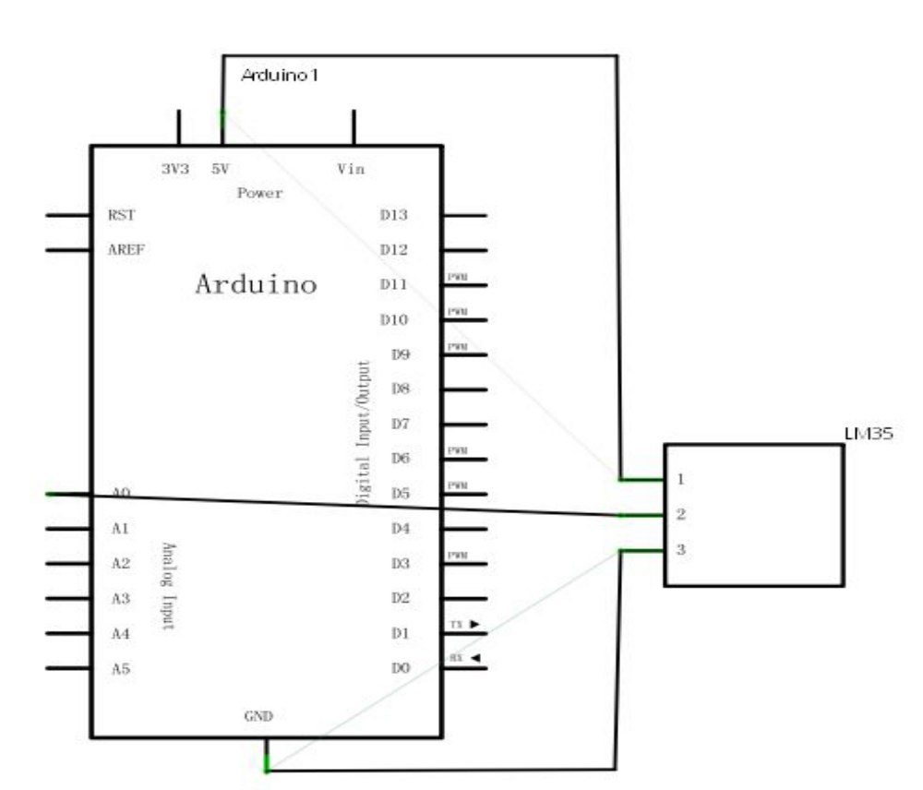
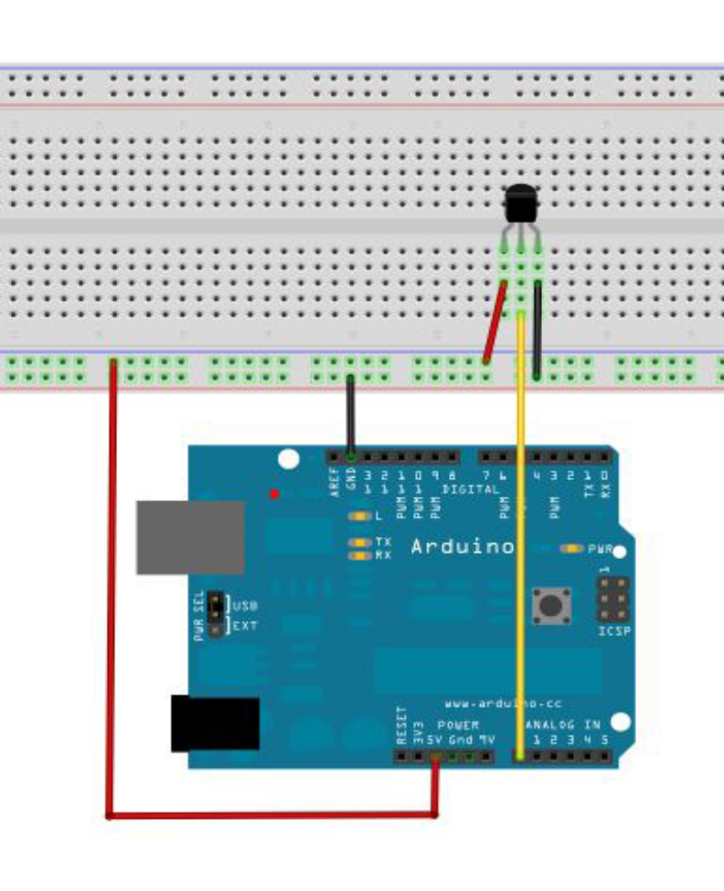
Refer to the source:
int potPin = 0; / / define the analog interface 0 connection LM35 temperature sensor
void setup ()
{
Serial.begin (9600) ;/ / set the baud rate
}
void loop ()
{
int val ;/ / define variables
int dat ;/ / define variables
val = analogRead (0) ;/ / read the sensor analog value assigned to val
dat = (125 * val) >> 8 ;/ / temperature formula
Serial.print ("Tep:") ;/ / output as Tep strings on behalf of temperature
Serial.print (dat) ;/ / output displays the value of the dat
Serial.println ("C") ;/ / AS output C string
delay (500) ;/ / delay 0.5 seconds
}
After downloading the program to open the monitor window you can see the current temperature.

